Practical No 6
Functions
Aim : Write a Python program to demonstrate user defined functions.
Programs using functions, Passing arguments and returning values
- Function to Calculate Area of a Circle
Code:
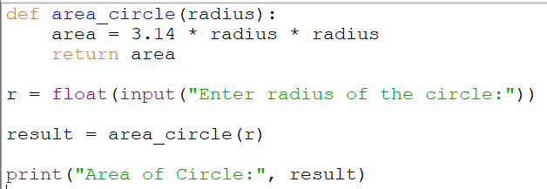

Output:
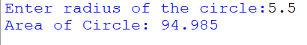

- Function to Check Even or Odd
Code:
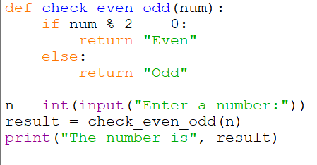

Output:
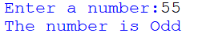

- Function to Find Larger of Two Numbers
Code:
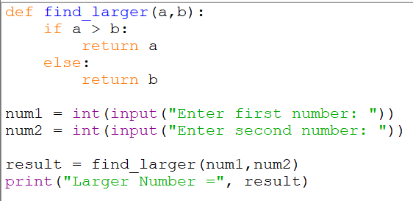

Output:
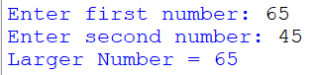

- Function to Calculate Factorial
Code:
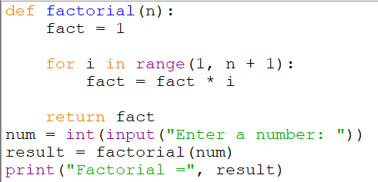

Output:
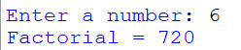

- Function to Calculate Simple Interest
Code:
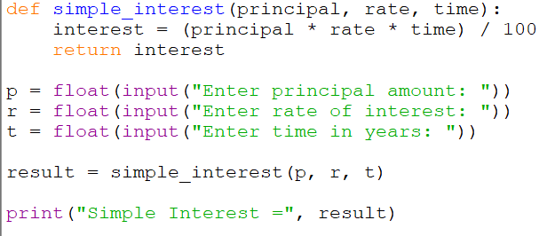

Output:


